**DAILY ONLINE ACTIVITIES SUMMARY**

|  |  |  |  |  |  |  |  |  |
| --- | --- | --- | --- | --- | --- | --- | --- | --- |
| **Date:** | **22-06-2020** | | | | | **Name:** | **Rakesh M Kotian** | |
| **Sem & Sec** | **8 th sec-b** | | | | | **USN:** | **4al16cs072** | |
| **Online Test Summary** | | | | | | | | |
| **Subject** | | **-** | | | | | | |
| **Max. Marks** | | **-** | | **Score** | | | **-** | |
| **Certification Course Summary** | | | | | | | | |
| **Course** | **Python for machine learning** | | | | | | | |
| **Certificate Provider** | | | **Great learning** | | **Duration** | | | **6 hours** |
| **Coding Challenges** | | | | | | | | |
| **Problem Statement:**  to cyclically rotate an array by one | | | | | | | | |
| **Status:solved** | | | | | | | | |
| **Uploaded the report in Github** | | | | | **yes** | | | |
| **If yes Repository name** | | | | | **Rakeshkotian08** | | | |
| **Uploaded the report in slack** | | | | | **yes** | | | |

Online Test Details: (Attach the snapshot and briefly write the report for the same)

Certification Course Details: (Attach the snapshot and briefly write the report for the same)

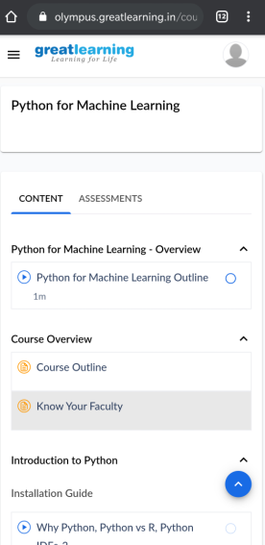

|  |
| --- |
| // C++ program to rotate an array by  // d elements  #include <bits/stdc++.h>  using namespace std;  /*Function to left Rotate arr[] of  size n by 1*/  void leftRotatebyOne(int arr[], int n)  {  int temp = arr[0], i;  for (i = 0; i < n - 1; i++)  arr[i] = arr[i + 1];  arr[i] = temp;  }  /*Function to left rotate arr[] of size n by d*/  void leftRotate(int arr[], int d, int n)  {  for (int i = 0; i < d; i++)  leftRotatebyOne(arr, n);  }  /* utility function to print an array */  void printArray(int arr[], int n)  {  for (int i = 0; i < n; i++)  cout << arr[i] << " ";  }  /* Driver program to test above functions */  int main()  {  int arr[] = { 1, 2, 3, 4, 5, 6, 7 };  int n = sizeof(arr) / sizeof(arr[0]);  // Function calling  leftRotate(arr, 2, n);  printArray(arr, n);  return 0;  } |